**Handouts on Image Interpretation**

*Authors: Pradesh Jana, Ritu Anilkumar, , Dhruval Bhavsar Prepared On: 20 November 2023*

Satellite data is available at many different resolutions, spectral regions and revisits. Depending upon our application, we need to select the optimal sensors. For eg: surveillance activity will require constant monitoring. This will need a camera of high repetivity, precision agriculture will require revisits in the range of a few days to weeks but will require very high resolution imagery covering the wavelengths that the crops are responsive to etc. Some of the Indian satellite data can be downloaded from Bhuvan website hosted by the National Remote Sensing Centre, ISRO, Hyderabad. Foreign satellite data is available at the respective space organization web pages and data portals. Landsat series of satellites is a commonly used dataset and we will be using the same for our exercise. The data can be downloaded by creating an account on the Earth Explorer portal of USGS and the freely available data may be downloaded through the same. The link for data download is as follows: https://earthexplorer.usgs.gov/

The study locations can be selected by clicking on the map. Additional filtering based on date can be set as required:

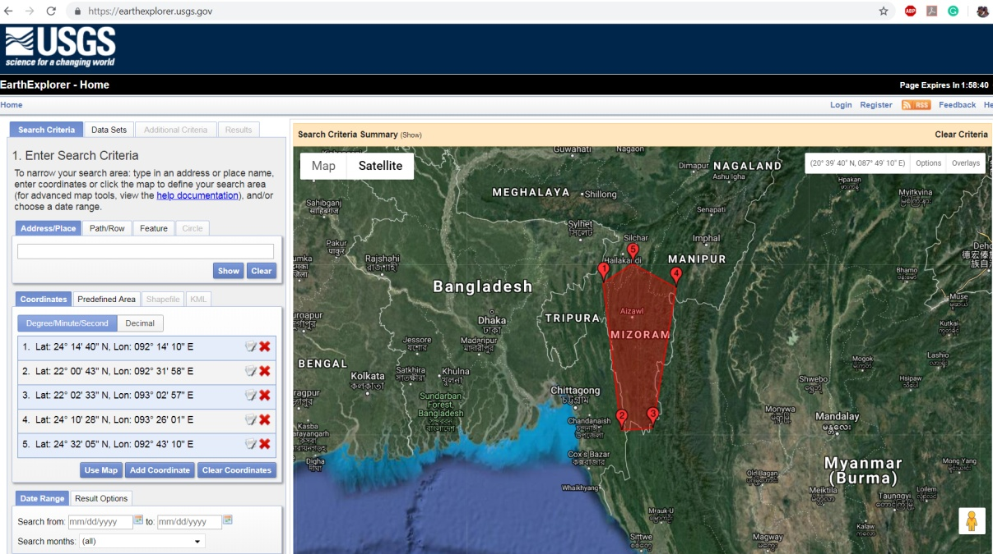

The datasets of interest can be selected. In our case, we will download the Landsat 8 Level 1C dataset available for free download upon login.

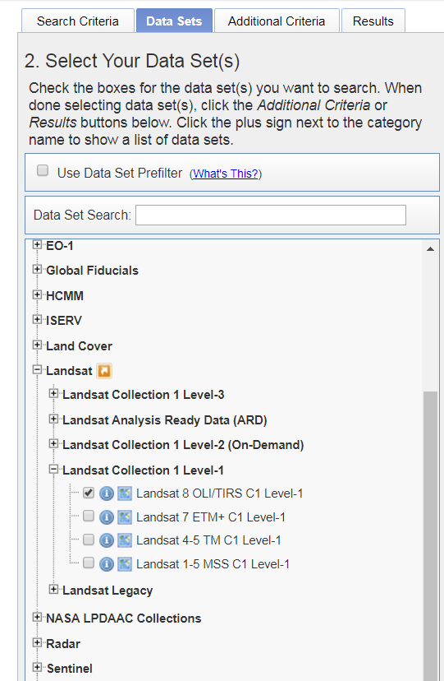

Additional criteria such as imaging conditions, cloud cover etc can be set under the additional criteria tab. Next, the results are observed.

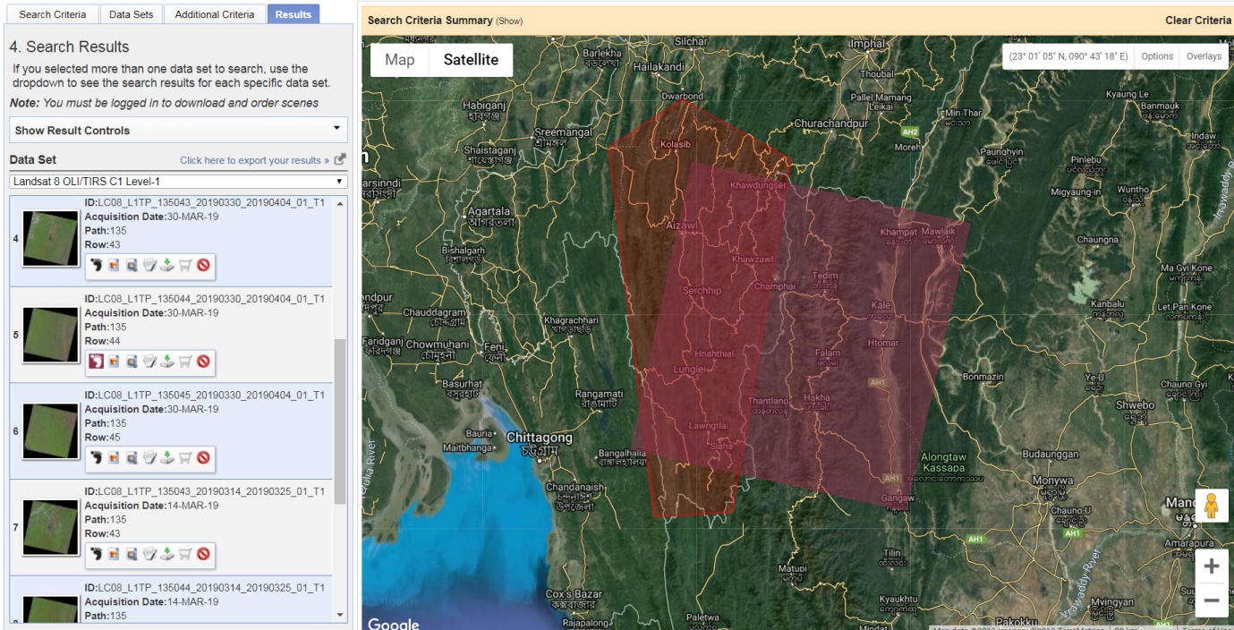

The level 1 Geotiff products are to be downloaded. The image will be in a .tar.gz format. These are to be unzipped to obtain the images as seen in the folder below:

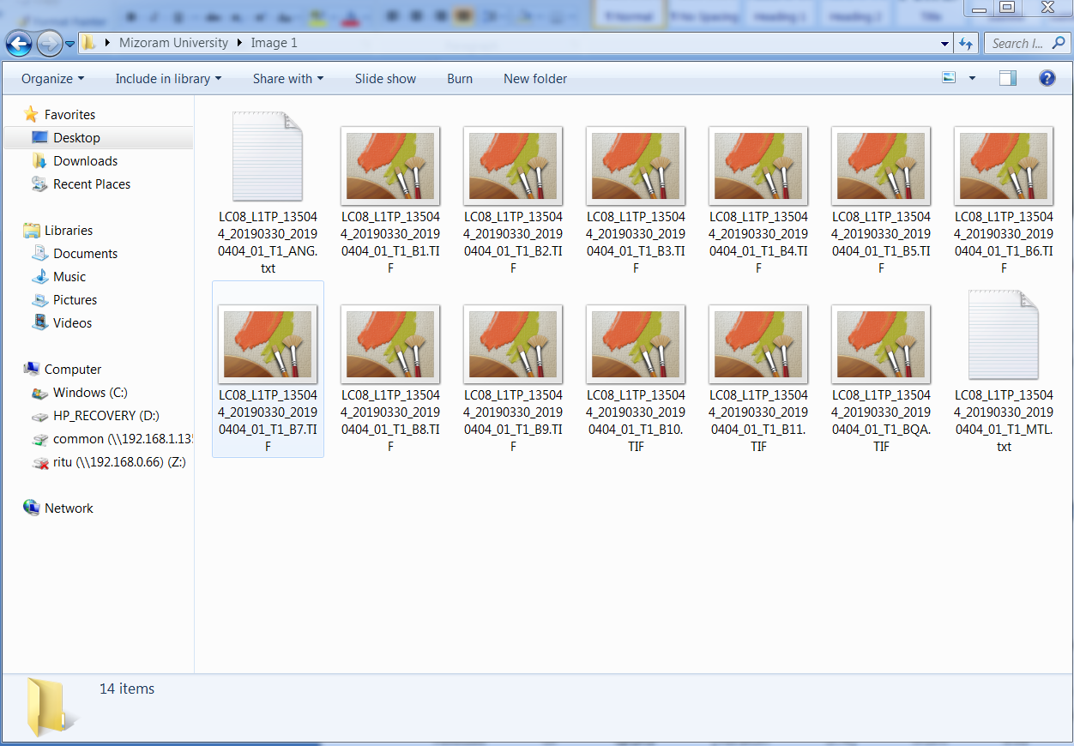

You will notice there are a number of images (5 VNIR: B1-B5, 2 SWIR: B6 and B7, 1 15m/px panchromatic: B8, 1 cirrus: B9 and 2 TIR: B10 and B11 ) within the folder. Each of these images are images of the study region corresponding to a particular wavelength (band). The standard viewers of your computers might not be able to visualize these images. They are visualized using remote sensing and GIS software. We are using the open source software QGIS for all our studies in this workshop. You may download and install the long term release of QGIS (version 3.4) from this website: https://qgis.org/en/site/forusers/download.html

Launch the QGIS software.

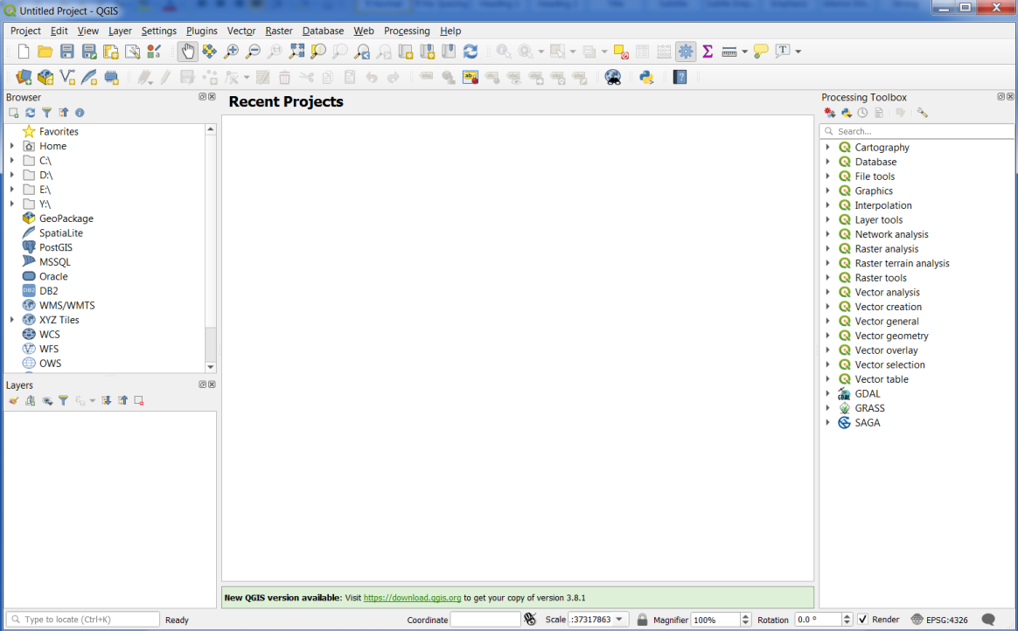

Click and drag the images to view it.

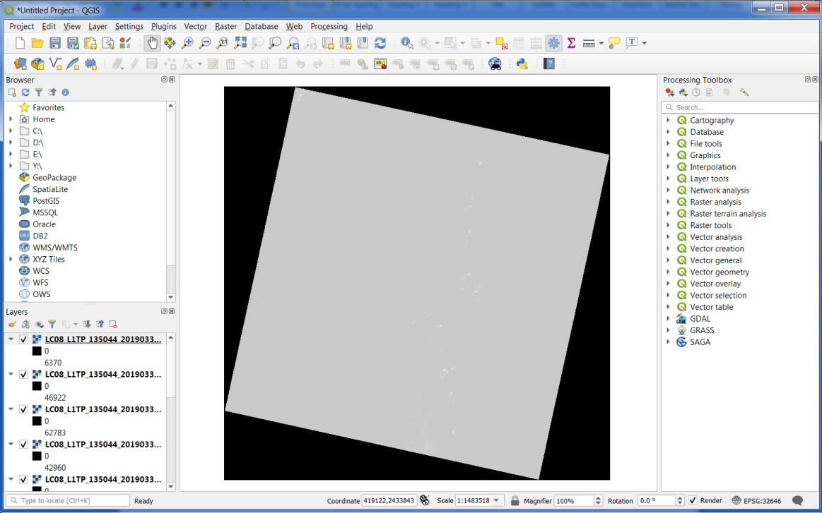

These individual bands need to be stacked into one image. This is achieved in QGIS through a process called Virtual Raster Creation. In the processing toolbox on the left of the QGIS window, type Build Virtual Raster and select the tool. If the processing toolbox is not visible, click the processing tab and select the processing toolbox.

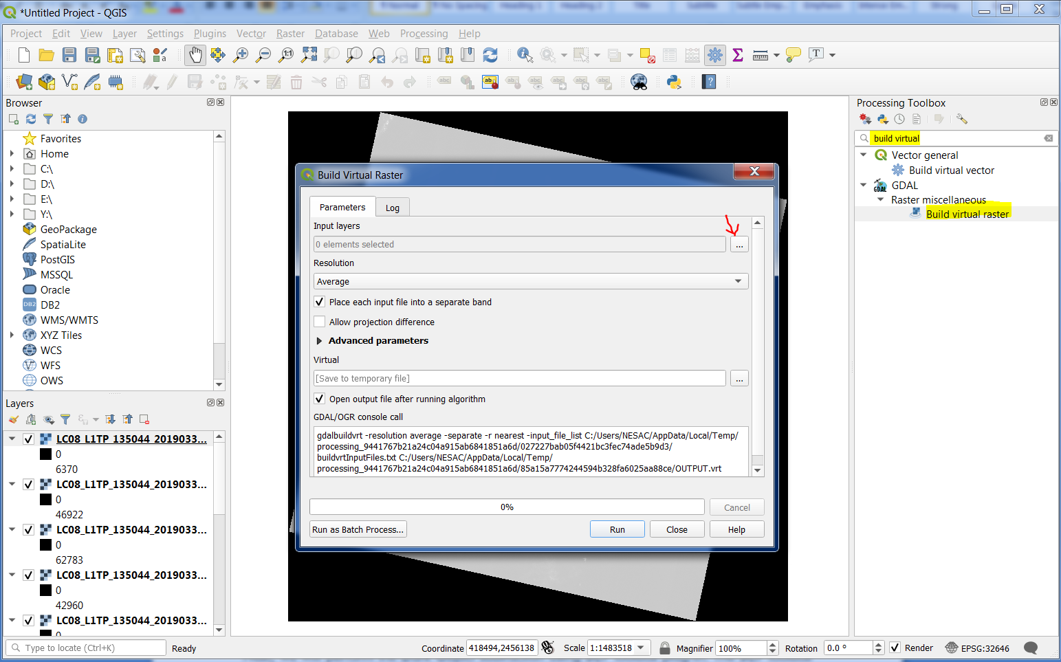

Click on the ... button next to Input layers to select the layers you would like to generate a virtual raster with. In the window that pops up, ensure that the order of bands is the order you wish to use them. In the below image, B10 and B11 are wrongly placed. Click and drag them to the bottom of the band list. Click Select All, click OK and run the tool.

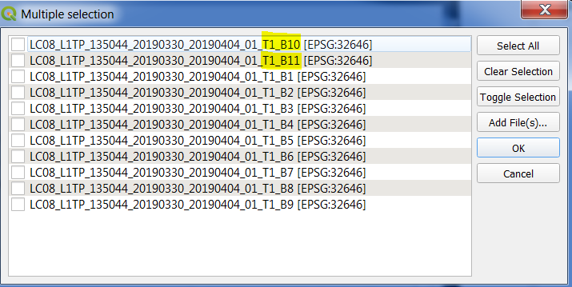

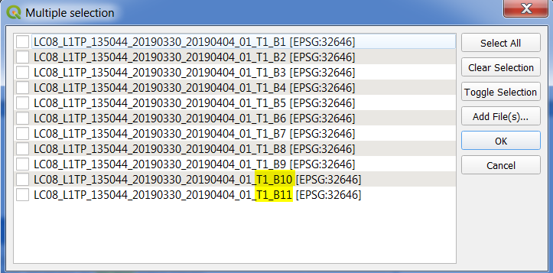

Once the virtual Raster is generated, the other layers are redundant and may be removed by right-clicking and selecting remove. The QGIS view is as follows:

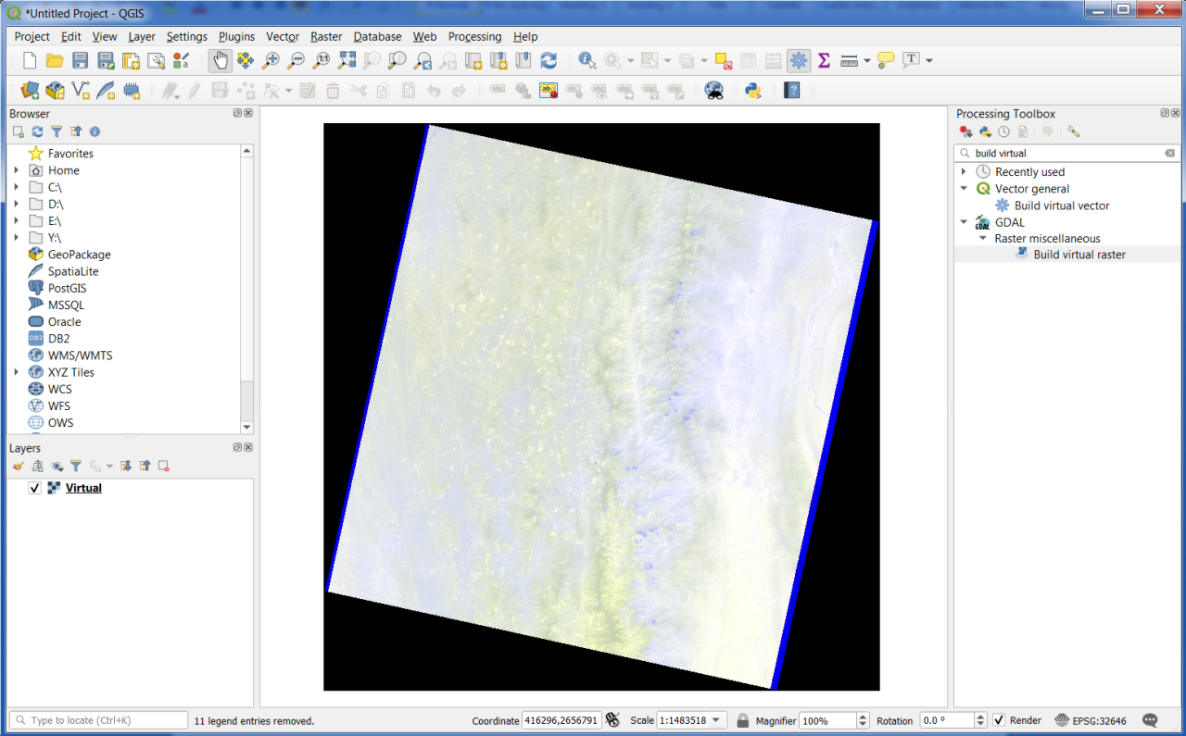

This is because B1 (Ultra-blue) has been assigned the colour red, B2 (Blue) -> green and B3 (Green) -> blue. In order to see the image the way humans can see it, we need to assign B4 (Red) to the Red channel, B3 (Green) to the Green channel and B2 (Blue) to the Blue channel. For this, right click on the Virtual Raster image and select properties.

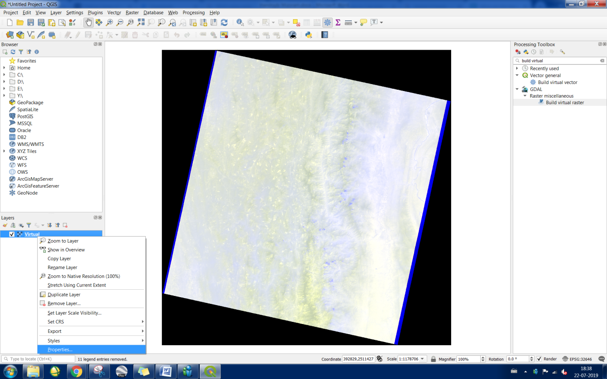

In the resulting window, change the bands under the Symbology option. Click apply and OK.

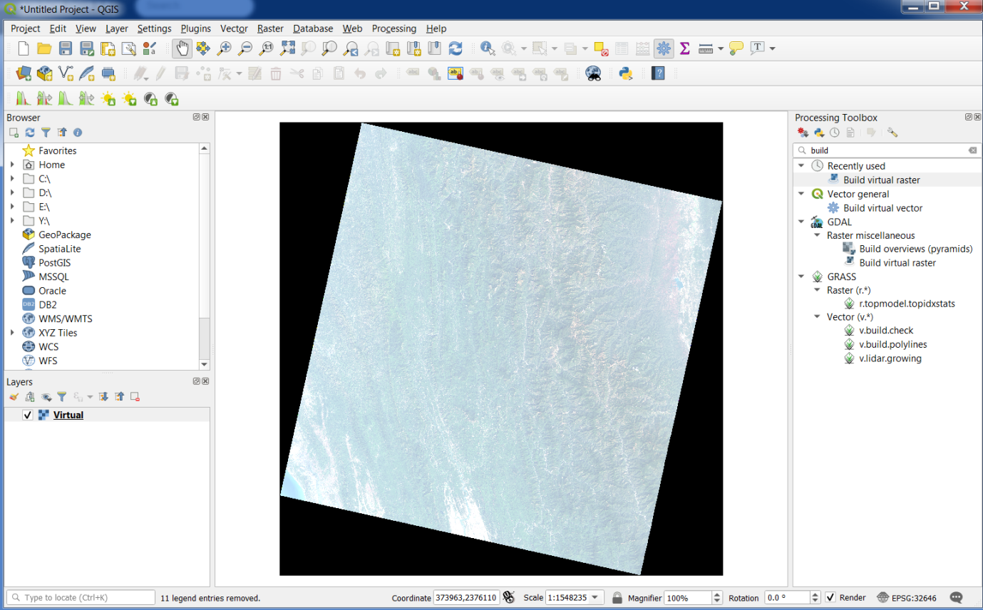

You will notice that the bands appear to be very unclear and lacks contrast. In order to enhance the image, we stretch the image. This can be done under the Properties>Symbology. Click on the Min/Max Value Settings and select the fourth option. Click apply and OK.

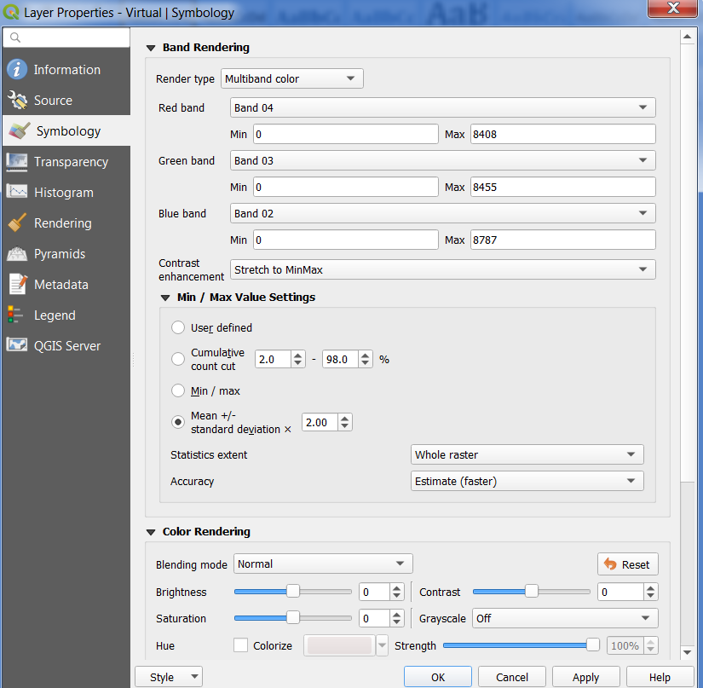

The image can still be further enhanced by stretching as per the histogram. For this, select the Histogram Stretch Option in the Raster Toolbar. In case the Raster Toolbar is not available, go to View>>Toolbars and check the Raster Toolbar.

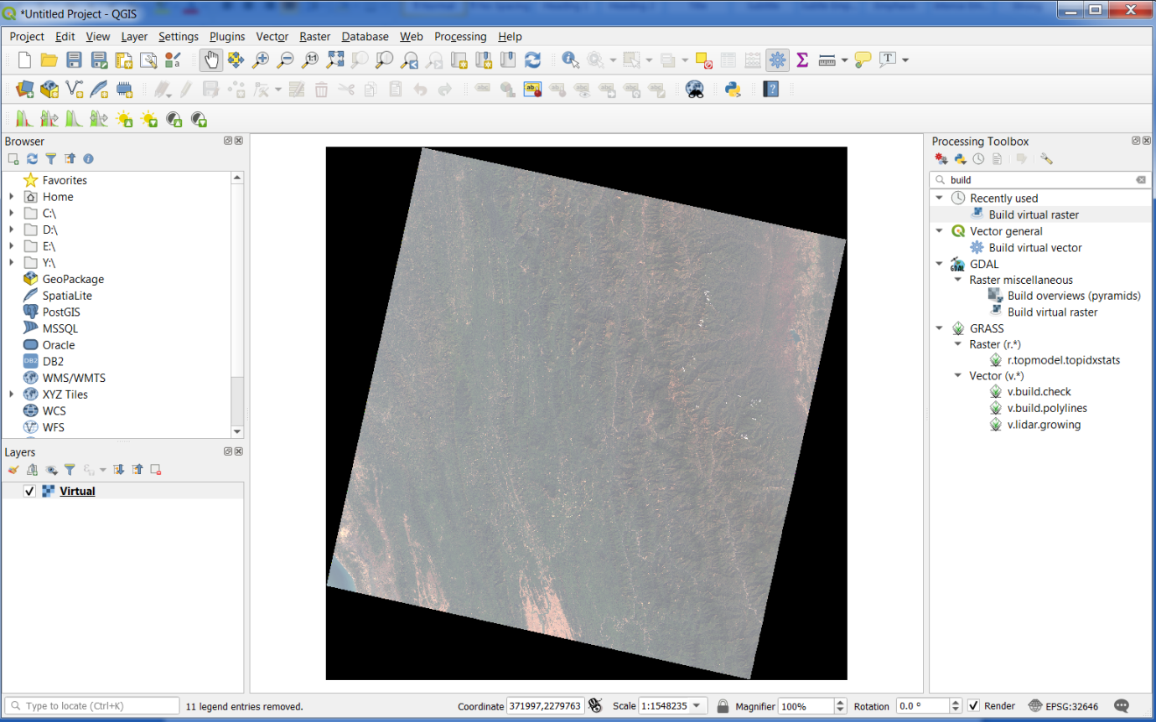

Experiment with all the above tools until you find a visualization you are comfortable with.

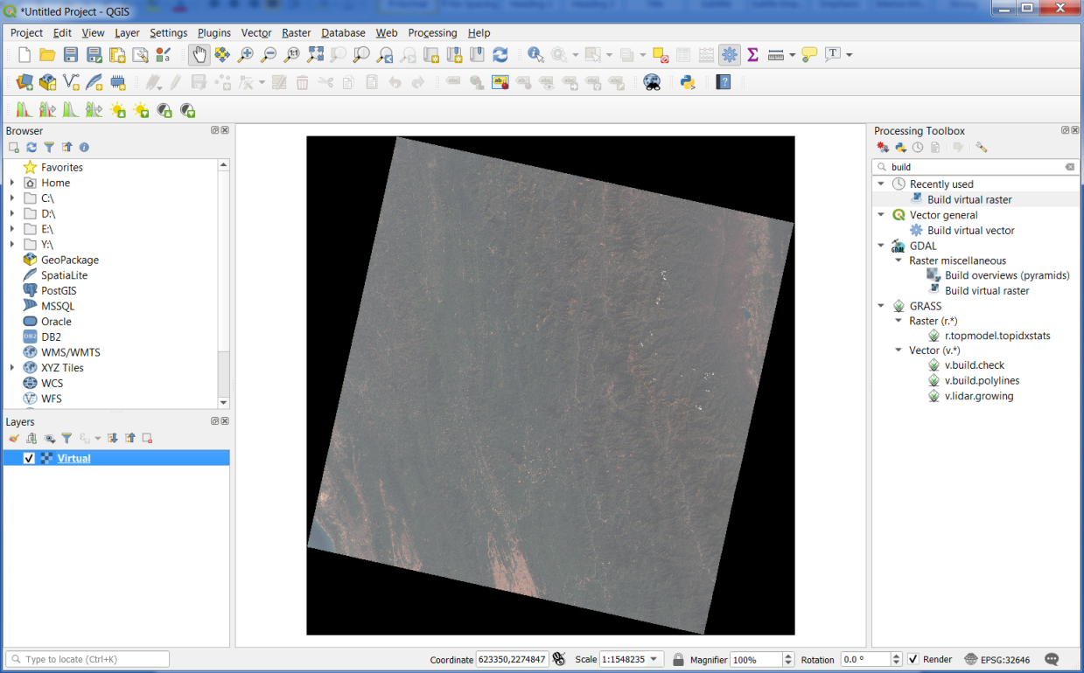

Now, we have viewed the images exactly like how humans view it. But the advantage of using remote sensing is that the remote sensing sensors can see beyond what we humans can see. The band 5 is NIR. Vegetation is particularly reflective in the NIR. So a commonly used image visualization is in the form of a false colour composite with B5 (NIR) being assigned the red channel, B4 (Red) being assigned the green channel and B3 (Green) being assigned the Blue channel. Experiment with the enhancement until you get a view like this:

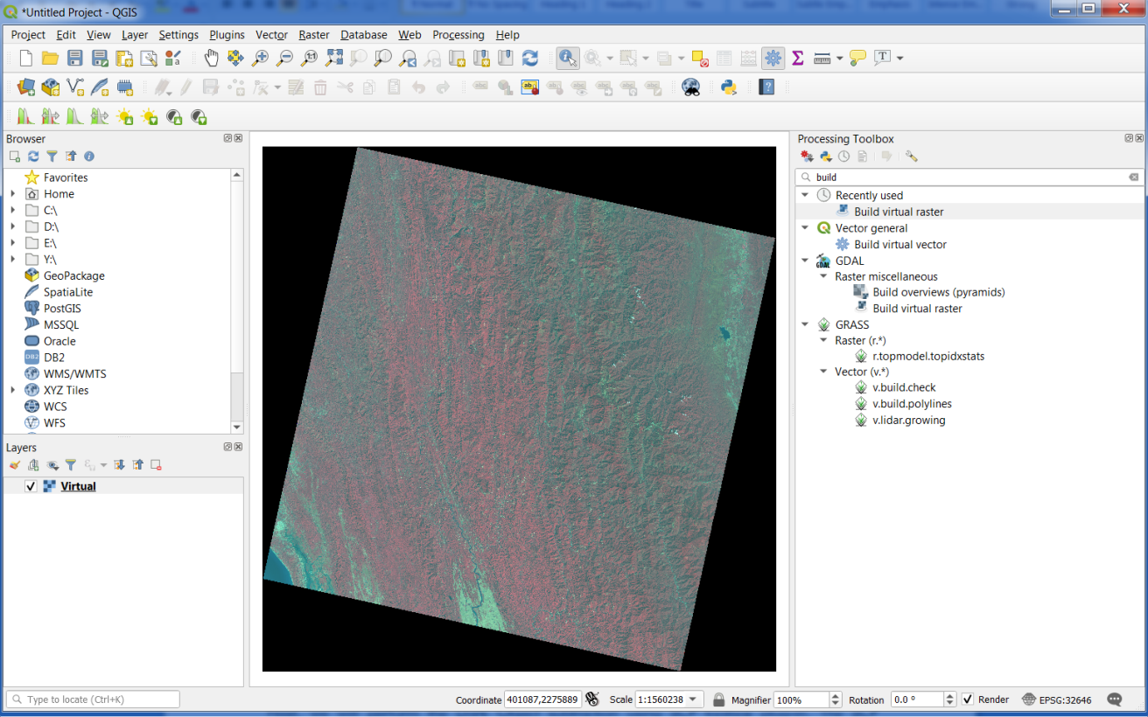

Before we proceed, the black border around the image can be removed by setting No Data constrain in the transparency. For this, right click on the Virtual Raster>Properties>Transparency. Set the Additional No Data value to 0 and click OK.

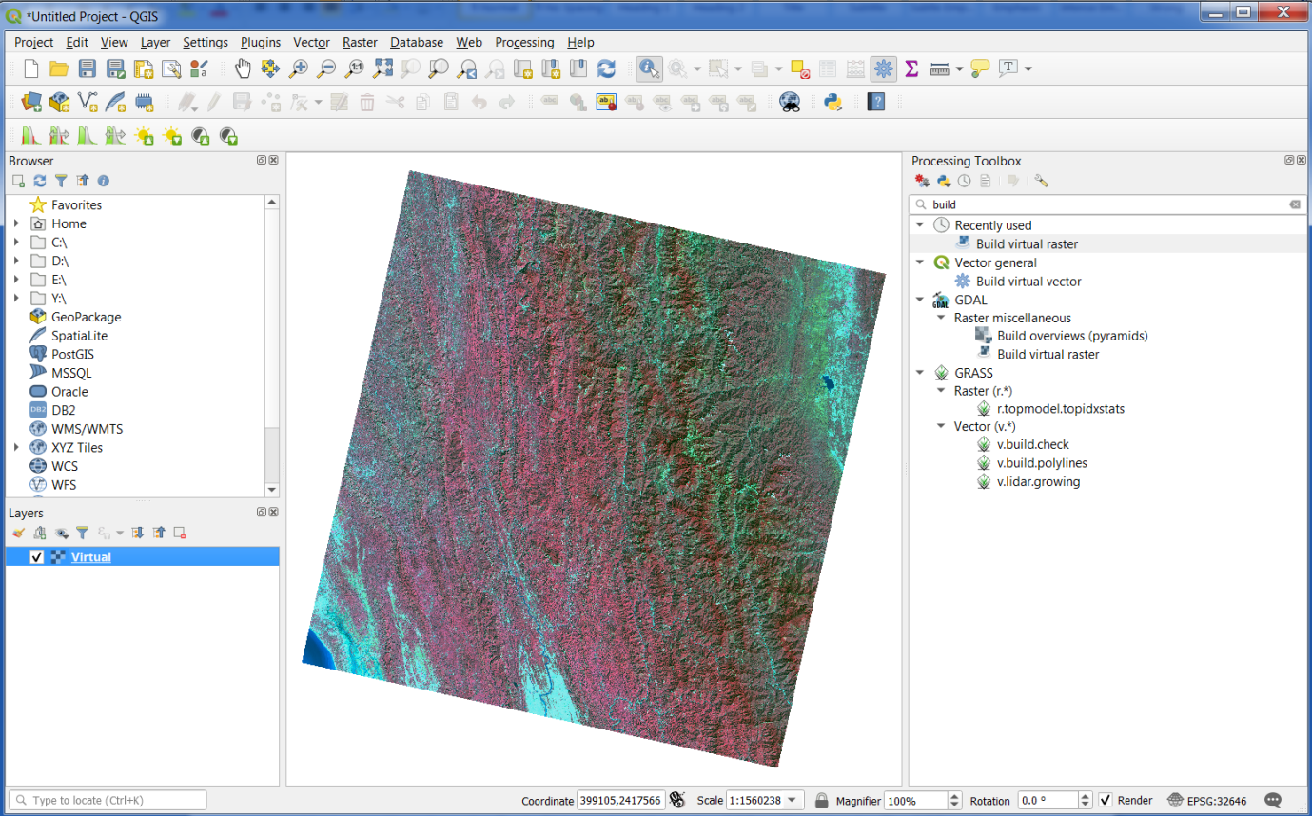

Next, we will perform the Dark Object subtraction using SCP toolbox plug-in. The SCP toolbox is an external plug-in you will have to install. For doing so, go to the plugins option on the toolbar and select Manage and Install Plugins. Under the resulting pop-up window, select All and search for the Semi-Automatic Classification Plugin (SCP) and click install.

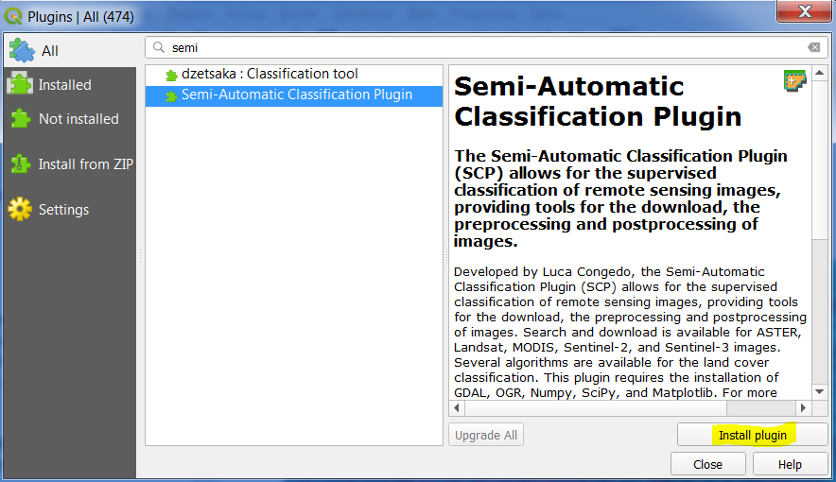

Open the SCP tool and select the pre-processing tab followed by the Landsat tab. Select the folder containing your images and the MTL file associated with it. Click on the Dark Object Subtraction (DOS) checkbox. This is a preliminary correction technique which scales down the image into relative reflectance. Also click the pan sharpen check-box if you wish to transform all the 30m/px images to 15/px images using the Band 8. Brightness temperature in Celsius option can be checked if you are using the thermal bands. Click Run.



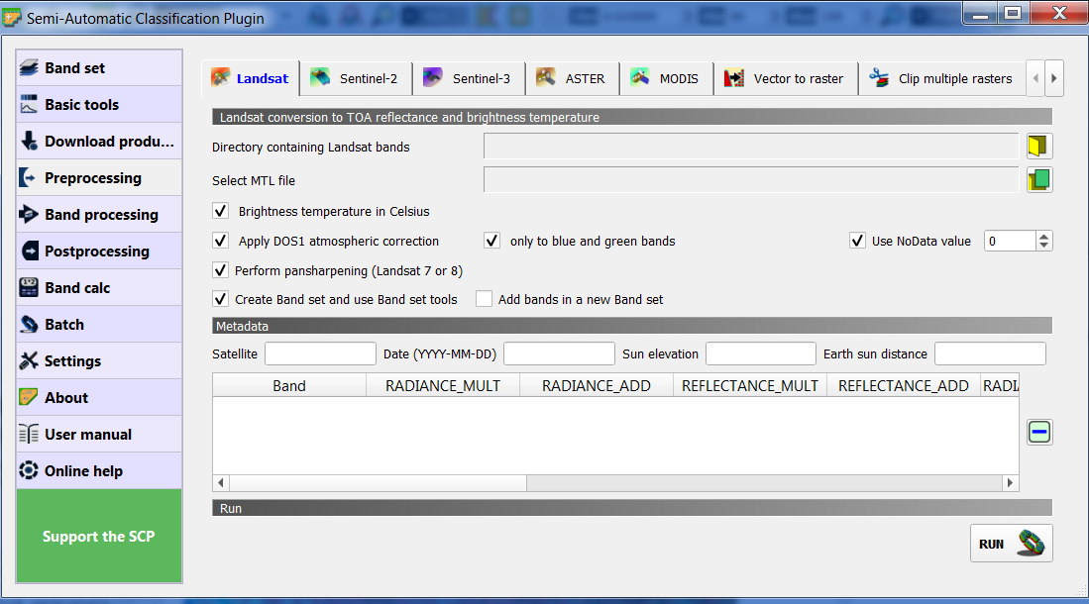

Our next task is to generate spectral indices. We will generate a commonly used vegetation index called Normalized Difference Vegetation Index (NDVI). NDVI is calculated as the normalized difference between the Near Infra-Red band and the Red band given by the following expression:

$$NDVI=\frac{NIR−Red}{NIR+Red}$$

The NDVI image is generated using the raster calculator. Go to the Raster tab and select Raster Calculator. Apply the formula given above and click run. An NDVI band is created.

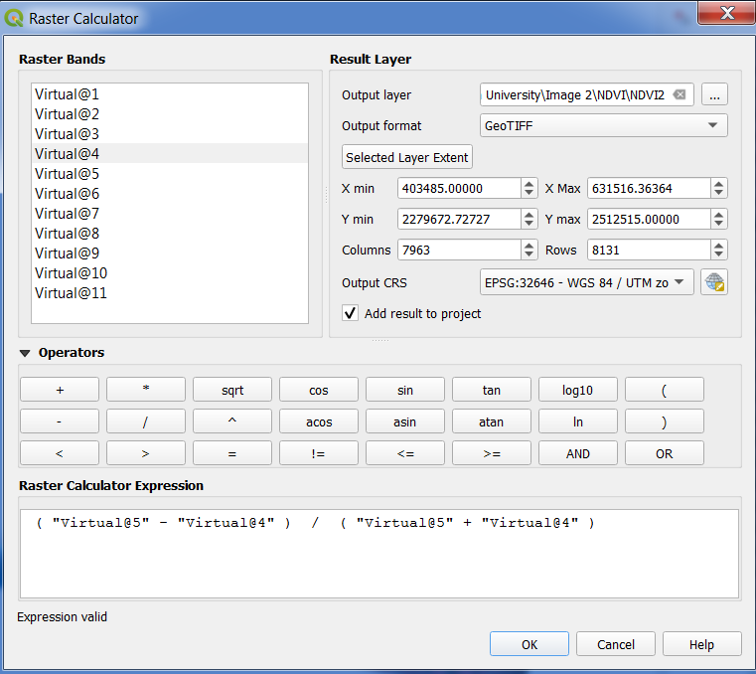

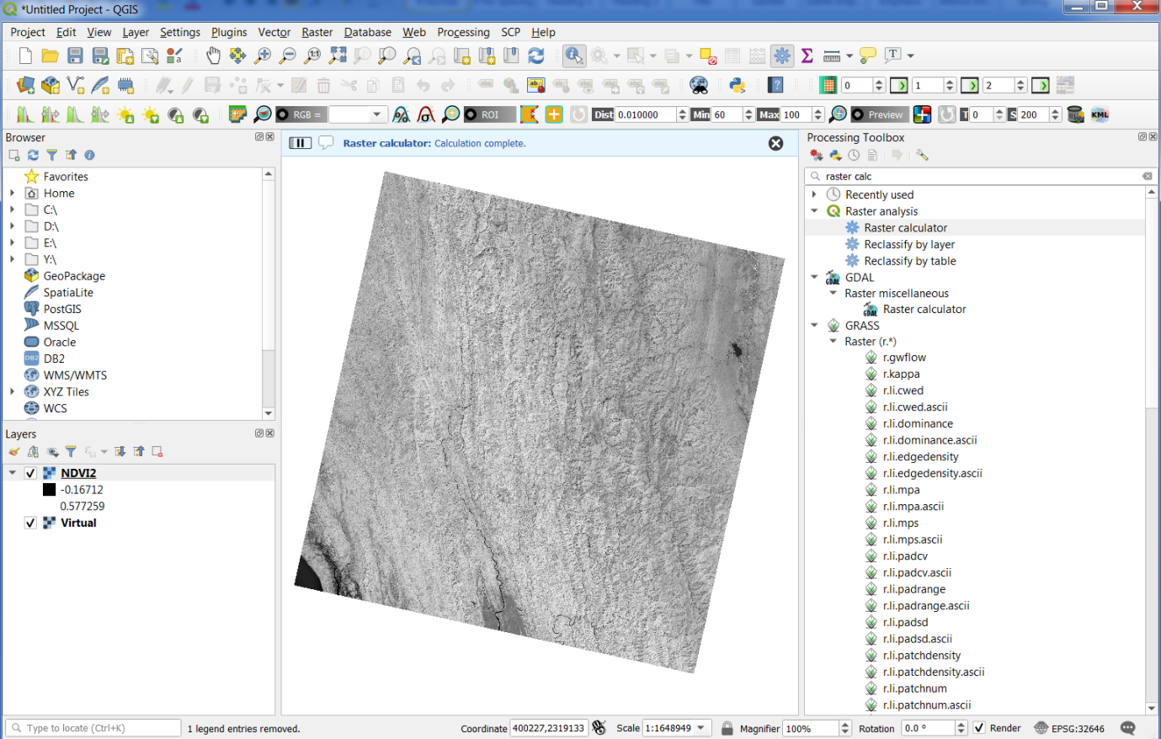

This NDVI can also be visualized in different colour for better understanding. This is done using the Properties>Symbology tab as before. Select the Single Band pseudo-colour option and experiment with the colorization parameters.

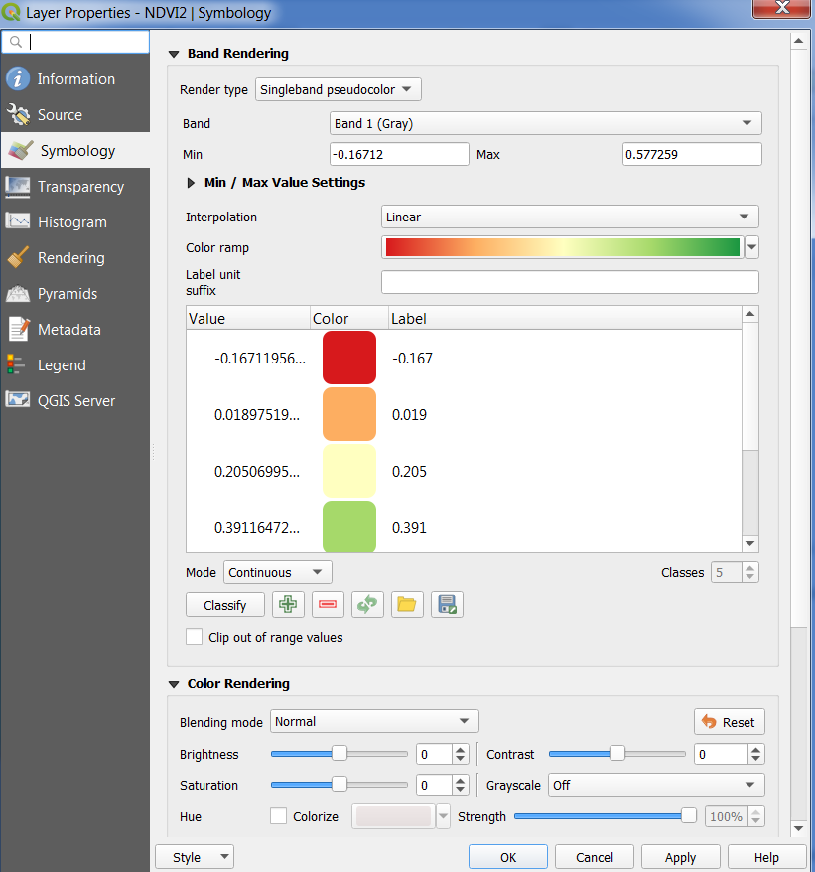

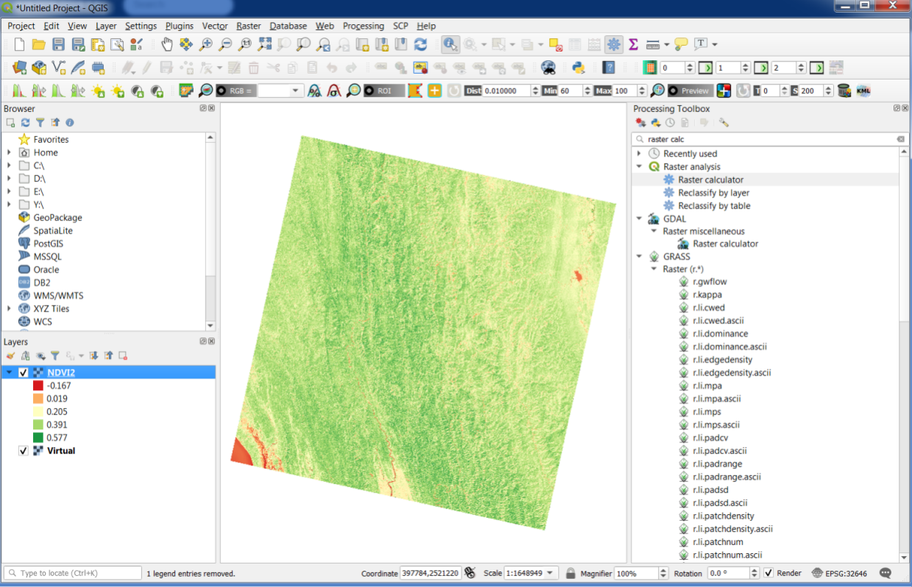

NDVI is an important parameter to estimate vegetation. As vegetation has a very high reflectance in the NIR and minimum reflectance in the Red, NIR reflectance dominates and hence vegetation is characterized by high NDVI values. We can also use the raster calculator to threshold the raster values and select vegetated regions from the above. This uses the logical expressions on raster. We leave this as an exercise for you to try.

**Theory on Image Interpretation**

Interpretation may be broadly termed as the indirect “Prediction of the terrain features by a combined process of deductive and inductive reasoning (logical explanation) aided by ground verification and extending clued to interpreted possibilities or science of interpreting objects from the photographs or image by using photo recognition elements.

Image interpretation is carried out in following four phases

1. Photo/Image-reading: - involving detection, recognition and identification.
2. Analysis: deals with the purpose or aim for which interpretation is carried out, and accordingly the boundaries of interest are delineated
3. Classification: whereby the comparison of different units is made by their physical and cultural features.
4. Deduction: is a combined process of photo/image observation supported by observation from other sources e.g. existing literature.

**RECOGNITION ELEMENTS**

The interpretation of images and photographs is primarily based on the qualitative use of the following recognition elements for visual ‘reading’ ‘analysis’ and ‘interpretation’.

**A. Photographic/Photo Elements:** To perform regional analysis, view the terrain in three dimensions, interpret images obtained from multiple regions of the electromagnetic spectrum, and perform change detection, it is customary to use principles of image interpretation that have been developed through empirical experience for more than 150 years (Robben, 1960: Estes et al. 1983; Schott, 1997). The most fundamental of these principles are the *elements of image interpretation.* In other words it is also may be known as *photographic elements* that are routinely used when interpreting aerial photographs or analyzing image. The elements includes

1. Tone 2. Texture

3. Pattern 4. Shape

5. Size 6. Shadow

**Tone:** - Tone is the intensity of grey levels in black and white photographs or imagery. It is the measure of the amount of light reflected by an object and actually recorded on a black and white photographs or imagery, as various shades of grey. Real world surface materials such as vegetation, water and bare soil often reflect different proportions of energy in the blue, green, red, and near-infrared portions of the electromagnetic spectrum. The amount of energy reflected from each of these materials in specific wavelengths can be plotted and create a spectral reflectance curve, sometimes called a spectral signature. Colour tones are generally useful when colour photography is taken. The shades of grey recorded on a black and white photograph can be analyzed by

1. Hunan eye + brain ii. Densitometers
2. Micro-densitometers

The various terms used to designate the tonal character in visual interpretation are

1. **Very dark tone/dark grey tone**

* Found commonly in rough surface, wet impervious soils, dense vegetation, high groundwater etc.

1. **Light grey/medium grey/very light grey**

* Commonly observed in smooth surface, arid regions, coral sands, sand bars, snow or ice, fresh and unweathered rock outcrops, etc.

1. **Mottled tone**

* Common in lithological or porosity changes

1. **Banded tone**

* Interbedded / alternating rocks of different composition/colouration, e.g. sandstones and shales

1. **Homogenous tone**

* Common in areas of uniform composition/character and homogeneous rock types
* **Speckled tone -** Rough surface, granular terraces in semi-arid zone with vegetation clusters

However, photographic tone is subject to wide variations, and there are limitations in its usefulness as a recognition element because of the factors influencing it as follows:

1. **Terrain and object condition**
2. Location of the object with respect to the sun, b. Geographical location of the object, c. Haze in the atmosphere, d. Angle of reflected light, e. Orientation of surface, f. Moisture and vegetation, g. Weather condition, h. Spectral ranged used
3. **Laboratory Methods and Printing condition**
4. Quality of negative. B. Printing techniques, c. Printing material

**Texture:** - Texture is the characteristic placement and arrangement of repetitions of tone or colour in an image or photograph. In other words, it may be defined as tonal variation within a limit which is small enough to be discerned/mapped individually/separately but resolvable in the image/photograph*.* Colwell (1952), defined texture as ‘the frequency of tone change within the image ….. and …is produced by all aggregate of unit features too small to be clearly discerned individually on the photographs’ or ‘ the aggregate arrangement of minute images expressed by tone, shape, size and pattern’.

Texture is a function of photo scale and depends upon magnification and reduction. The texture due to tonal change within the image may be called a photographic texture. The followings terms are used in describing the texture:

1. Coarse – rough, b. smooth – fine, c. even – uneven, d. banded, e. mottled, f. speckled, g. granular, h. linear, i. blocky, j. matted, k. wooly etc,.

The term texture has different meanings when used with specific field of studies as given below

1. Topographic texture- the term is used to described the degree of dissection of land surface.
2. Drainage texture or drainage density – wide spacing of streams results in coarse texture of low drainage density and close spacing of streams results in fine texture or high drainage density.
3. Soil texture – it must be interpreted from other recognition elements such as porosity, drainage, grain size, vegetation etc.

**Pattern: -** Pattern is an important recognition element and also it is a very diagnostic characteristic of many features or objects. It represents the orderly or the typical spatial arrangement of objects or features in the landscape such as geological, topographic, vegetation, cultural etc. The objects may be arranged randomly or systematically. They may be natural or man-made. If the features that makes a pattern becomes too small to be identified as on small scale photographs or image, they may then form a photographic texture. Random, systematic, circular, centripetal, oval, curvilinear, linear, radiating, rectangular, block, hexagonal, pentagonal, octagonal, etc., are some of the terminologies used in describing the texture.

**Shape**: - Shape refers to the outline of an object or it concerns the general form or configuration of various types of features. It is also considered under terrain elements. Shapes may be man-made such as dams, playgrounds/stadium, roads, buildings etc. which can be easily identified on the basis of their typical shape & layout or natural such as sandbars, alluvial fan, terraces (fluvial or man-made) etc. Various natural or man-made features present on the earth’s surface can be identified by their distinct shapes. Some of the examples are given below

Fig: 7, Curvilinear

Fig: 8, Systematic,

Triangular

**Size: -** Size is defined as ‘a measure of surface or volume dimension of an object. The size of an object is one of the most distinguishing characteristics and one of the most important elements of image/photo interpretation. Measuring the size of few well-known objects in an image such as car length, road, railroad width, size of the typical single house in the area, etc. allows us to understand the size of unknown features in the image and eventually to identify them. However, an idea of the size of an object can be obtained only after the scale of the image or photographs is known. Size, when considered in conjunction with shape and association is a very useful parameter. Field dimensions of major sports such as baseball, football and cricket ground, tennis are standardized worldwide. If these features are visible within an image, it is possible to determine the size of other objects in the scene by comparing their dimensions with those of the known object dimension.

**Shadow:** - Shadow cast by objects is at times quite informative. It may be natural or man-made objects/features. It gets more pronounced on low-sun angle images.

Fig: 15, Shadow cast man-made feature

Fig: 14, Shadow cast man-made feature

However, most remote sensor data is collected within plus-minus 2 hours of solar noon to avoid extensive shadows in the imagery. This is because shadows from objects can obscure other objects that might otherwise be detected and identified. On the other hand, the shadow cast by an object may be the only clue to an object’s identify. For example, consider the shadows cast by two people standing on a pier and the shadow cast by bench. Similarly, shadows cast by signs or bridges are often more informative than the objects themselves in vertical aerial photographs. It may be useful in interpretation of tree type e.g. conifers, generally having a pointed canopy profile casts long slender shadows as compared to broad canopy. The type of tree in turn may have a relation with climatic condition of the area or region and underlying geologic material.

1. **Site/situation/association:** Site, situation and association elements of image interpretation are rarely used independently when analyzing an image. Rather they are used in interactive manner to arrive at a conclusion. A site has unique physical and/or socioeconomic characteristics. The physical characteristics might include elevation, slope, aspect, and type of surface cover e.g. bare soil, grass, shrub/scrub, forest, water, concrete, housing etc. and socioeconomic include the value of the land, adjacency of to water etc. Association refers to the fact that when we find a certain phenomena or activity, we almost invariably encounter related or associated features or activities. One of the example is a sawmill sited on a flat terrain-associated with large pile of raw timber, a furnace to dispose of wood waste products, and an extensive processing facility. Hindustan Paper Limited factories located at Nagaon and Silchar, Assam. Both the sites are on gentle foot hill slope or piedmont slope with large pile of bamboo as raw material, well connected to highway and railroad often used for transportation of raw material as well as dispose off the finished products for marketing. Clear visibility of smoke emanating from the chimney of the processing unit moving towards south which is in turn gives the logical understanding of wind direction at the time of imagery.

The above elements of photo interpretation are used to make observation on photographs and images. However, interpretation in terms of various physical attributes and phenomena have to be based on sound knowledge of the relevant scientific discipline.

**C. Geotechnical or Terrain Elements**

After the preliminary examination of photographs or satellite images the elements of photo interpretation are applied to study features on the Earth’s surface. It includes the study of

a. Landform, b. Drainage pattern and density

c. Vegetation d. Landuse e. Erosion

**Landform: -** Analysis of landform and physiography permits the identification of soils materials, and rock type etc. The shape, pattern and association of some landform features can be helpful in identifying geological features. For example, sand dunes have a peculiar typical pattern and shape, and are produced by wind action which in turn indicates arid eco-climate. Presence of river terrace, point bars, backswamps, natural levee, ox-bow lake , meander scar, palaeochannels etc., indicate fluvial environment. Presence of cuesta landforms showing clear dip slopes indicate sedimentary rocks having variable erodibility whereas presence of mesa indicates horizontal landform . Therefore, a systematic study of landforms is generally a pre-requisite in nearly all geological photo interpretation.

1. **Drainage pattern & density**: - Drainage is one of the most important geotechnical elements for geological photo interpretation. A drainage pattern is the planimetric arrangement of streams, etched into the land surface by a drainage system. In other words, it is the spatial arrangement of streams which are generally the characteristics of a given soil, rock type, structure, or of a complex of several materials. Some of the examples are dendritic pattern , trellis pattern, radial pattern , parallel pattern, etc. Dendritic drainage is a tree like pattern found mostly in horizontal to gently dipping sedimentary rocks and uniformly resistance crystalline

rocks and they are mostly control by structures. Trellis drainage pattern are generally developed as sub-parallel pattern and found in folded strata of various resistance rocks. In radial drainage pattern, streams are coming out from a particular area in all direction which indicates topographic high such as domes, mesa, conical hills etc. A stream pattern is the design formed by a single drainage way e.g. braided stream, meander etc.Drainage density can be described as fine, medium and coarse. Drainage is said to be internal when few drainage lines are seen on the surface and appears to be mostly sub-surface, e.g. commonly in limestones and gravels. External drainage refers to cases in which the drainage network is seen to be well developed on the surface. Low drainage density (coarse-texture) implies porous and permeable rocks such as gravels, sands and limestones. High drainage density (fine-texture) implies impermeable lithology, such as clays, shales etc. Drainage anomaly is a difference in part of a drainage system which does not conform to the overall pattern.

Fig: 25, Dendritic

Fig: 28, Braided

1. **Vegetation: -** Vegetation in an area is controlled by climate, altitude, microclimate (local conditions), geological/soil factors and hydrological characteristics. The occurrence of plant association in different climate and altitude is well known. However, vegetation may sometimes obscure significant geologic features, but it may also at times considerable help in the detection and mapping geologic features. Commonly, alignment or banding of vegetation is observed on remote sensing images, which may be related to lithological differences or structural features. In some cases, structural tectonic features such as faults, fractures and shear zones produce water seepage zones, along which vegetation may become aligned. This alignment may be picked up on the remote sensing data especially in semi-arid to arid areas with generally scant plant covers . Sometimes vegetation used as indicator of environment e.g. willows are known to grow in areas of high moisture content and indicate humid climate, xyrophytic plants develop in an area indicates arid echo system. Vegetation at times acts as geo-botanical indicator and helps in mineral exploration and also indicates water table conditions in general.
2. **Landuse: -**Landuse may be defined as use of land by residence of the country, from farms to golf courses, houses to fast food establishments, hospital to graveyard. In other words, it refers to the utilization of the land for any given purpose by men such as cultural, agricultural or natural activities.When some piece of land is not put to any use then it is referred as wasteland. Sometimes, types of landuse in a particular area give rise to useful information on landform and the underlying materials/soil. Some examples are alignment of settlement along the river course may be interpreted as natural and or palaeo-levee which indicates the underlying material is a combination of sand, silt and clay , saline patches indicates a hidden information i.e. palaeochannel. If the settlement is circular in pattern it may be a topographic high/mound or dome. Presence of circular to semi-circular pattern of landuse with depression in the centre indicates areas of poor internal drainage with plastic nature of soil (e.g. clay).
3. **Erosion: -** Erosion refers to the relief variation between the outcrop and the surrounding background.If the outcrop stands out prominently against the flat

background, the resistance to erosion is high e.g. sandstone, quartzite. if the outcrop is occurred as an incidental manner the resistance to erosion is moderate e.g. siltstone . If the outcrop is occurred/exposed at the ground level the resistance to erosion is very low.

1. **Convergence of Evidence: -** Convergence of evidence implies integrating all the evidence and interpretations gathered from different photo recognition elements, i.e. considering all the evidence collectively leads to. The approach of convergence of evidence is very important of accurate geological interpretation, and for this a sound knowledge of geology is necessary.

**References and Suggested Reading**

* Gupta, R.P. Remote Sensing Geology. Springer-Verlang Berlin Hendelberg 2003, Printed in Germany (Second Edition).
* Pandey, S. N. Principles and Applications of Photogeology. John Wiley and Sons Inc. (December 1984).
* Jensen, J. R. (200, Remote Sensing of the Environment: An Earth ResourcePerspective. Prentice Hall Series in Geographic Information Science (Second Edition).
* Drury, S. A. (2001), Image Interpretation in Geology, 3rd edition, UK: Nelson Thornes.
* PG Diploma lecture notes (1998), Remote Sensing Applications in Geo-Sciences, IIRS Dehradun.

***